Project Report: Find the Nearby Hospital App

Title of Project:
Find the Nearby Hospital – Location-Based Emergency Assistance App

Name of the Innovator:
Siva Karuppu

Start Date:20/11/2025

End Date:22/11/2025

Day 1: Empathise & Define

Step 1: Understanding the Need

Which problem am I trying to solve?
Many people face difficulty finding the nearest hospital quickly during emergencies because they don’t know the exact location, hours of operation, or available facilities.

Who is affected by this problem?

Patients facing medical emergencies

Elderly people

Travellers

People in new cities

Caregivers and families

How did I find out about this?
☑ Interviews
☑ Observation
☑ Online Research
☑ AI Tools

---

Step 2: What is the problem?

Clear problem statement:
I am ideating a solution for people who struggle to find the nearest hospital instantly during medical emergencies due to lack of accurate location-based information.

Why is this problem important to solve?
During emergencies, even a few minutes of delay can risk a person’s life. Studies show that timely access to hospitals increases survival rates by over 40%. Providing a fast and simple way to locate the nearest hospital can save lives and reduce panic.

---

Take-home Task – Conversations Summary

Insights learned from 2–3 people:

People panic and forget known places during emergencies.

Many don't know 24×7 hospitals in their area.

Users prefer simple maps + one-click call options.

Women and elderly prefer apps showing emergency departments clearly.

---

Day 2: Ideate

Step 3: Brainstorming Solutions

1. A mobile app that shows nearby hospitals using GPS.

2. A WhatsApp chatbot that sends hospital locations based on user message.

3. A web app using Google Maps API to list nearest hospitals.

4. A voice-based AI assistant that speaks the nearest hospital & directions.

5. A simple emergency SMS service that sends hospital locations instantly.

---

Step 4: My favourite solution

A mobile-friendly web application that uses GPS to automatically detect the user’s location and show the nearest hospitals along with distance, contact number, and directions.

---

Step 5: Why am I choosing this solution?

Can be built quickly using free APIs

Does not require installation (web app)

Works on all smartphones

Simple UI for all age groups

Easy to expand with ambulance or pharmacy listings later

---

Take-home Task – AI Image

(Attach here your generated image of hospital-finder interface.)

---

Day 3: Prototype & Test

Step 6: Prototype – Building My First Version

What will my solution look like?
A clean web app where the user clicks “Find Nearby Hospital”, and the app automatically detects the user’s location using GPS. It displays a list of hospitals with:

Distance

Map direction button

Emergency call number

Open/close status

What AI tools will I need to build this?

ChatGPT: to generate code

Figma AI: to design the interface

Perplexity AI: to research APIs

Google Maps Platform (free tier)

GitHub Pages: to host the prototype

AI tools I selected:

ChatGPT

Figma AI

Perplexity AI

GitHub

---

Step 7: Test – Getting Feedback

Who did I share my solution with?

Friends

Family members

Trainer

ChatGPT for automated evaluation

Feedback I received

👍 What works well:

Accurate location detection
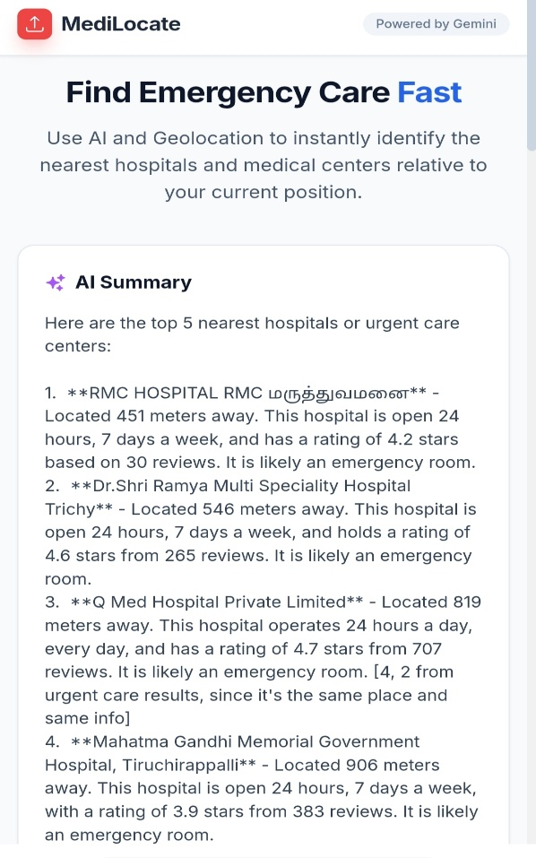
Simple UI
https://ai.studio/apps/drive/1h8rJDvj4LywSCiAblu1ZOGZcmlGD2Y75
One-click direction feature

🔧 What needs improvement:

Add ambulance numbers

Add 24×7 filter

Add distance sorting

---

Day 4: Showcase

Step 8: Presenting My Innovation

Final Project Title:
Find Nearby Hospital – Emergency Location Assistance App

---

Key Points of My Presentation

Problem Statement:
People struggle to locate the nearest and correct hospital during emergencies, causing dangerous delays.

My Innovation:
A web-based app that instantly shows nearby hospitals using GPS and provides directions, contact details, and emergency call options.

Feedback Received:
Users appreciated the simplicity but suggested adding ambulance services and filters for 24×7 hospitals.

Impact of My Innovation:
This solution helps users respond faster in emergencies, reduces panic, and can potentially save lives with quick and accurate hospital access.

---

Step 9: Reflections

What did I enjoy the most?
Learning how to use maps and GPS with code, and designing real-life solutions that can actually help people.

My biggest challenge:
Integrating location APIs and ensuring accurate hospital results for different locations.

